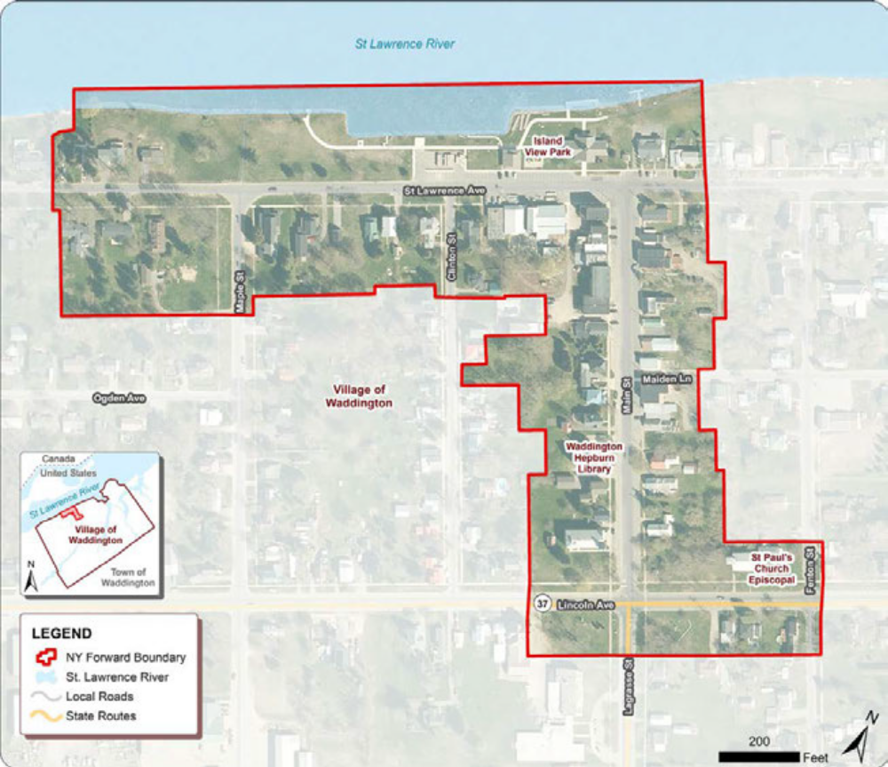
Overview: The Village of Waddington, through its NY Forward Small Project Fund, will offer funding assistance to eligible projects that enhance and strengthen the Downtown Revitalization Initiative (DRI) area. Immediate goals of this investment include streetscape enhancements, historic preservation projects and increased business and economic activity. Long-range goals include increased property values and property tax revenues, the creation of more job opportunities, attraction of new businesses and residents downtown, and ongoing, sustained vibrancy within the downtown neighborhood.

The Village of Waddington has been awarded $200,000 in NY Forward grant funds.

Note: Applications will be accepted between September 1, 2026 – September 30, 2026.

- Can anyone apply for the NY Forward funding?
  - Yes, as long as you meet the application and project criteria indicated below.

- Who is eligible for the NY Forward funding through this grant?
  - Applicants who are eligible for DRI or NY Forward assistance include property owners that are
    - Individual
    - For-profit entity
    - Not-for-profit entity
- Other application eligibility criteria for the NY Forward program include:
  - Property located within the Village of Waddington DRI designated boundary
  - Current on property taxes for all properties owned in the Village of Waddington. This includes taxes to the Village of Waddington, Madrid-Waddington Central School District, and St Lawrence County.
  - Free of open building code violations
  - Property is designated commercial or mixed-use (commercial & residential units)
  - Property is not receiving additional DRI or NY Forward funding
  - The applicant is able to finance the entire project and await reimbursement upon project completion
  - Applicants with rental units must be current with their Rental Operating Permits.
  - Project criteria for the NY Forward program include:
  - Building Renovation
    - Façade/storefront renovations
    - Interior fit-out, HVAC, and mechanical, electrical and plumbing (MEP)
    - Other permanent building improvements
  - Permanently affixed signage and awnings
  - Business Assistance
  - Permanent commercial machinery and equipment
  - Soft Costs
  - Architectural and design, engineering, and environmental testing.

  - Ineligible uses of DRI funds include:
  - Acquisition
  - Demolition
  - Improvements to churches, synagogues, and other religious structures
  - Improvements to municipally-owned buildings used for municipal purposes
  - Non-permanent fixtures, furnishings, appliances, electronics, security systems and business equipment
  - Site work or ancillary activities including septic systems or laterals, grading, parking lots, sidewalks, landscaping, fences, free standing signs
  - General maintenance
  - Reimbursement of cash payments
  - Material purchases or labor completed by property owner
  - New builds

- Can I perform the approved work myself or use my own business as the contractor?
  - No. Applicants/property owners may not act as the contractor or submit a quote from themselves or a business they own for work funded through the NY Forward program. All proposed work must be completed by a qualified, independent contractor, and applicants must obtain and submit contractor quotes in accordance with the program’s procurement and bidding requirements.

- Additional criteria with respect to the NY Forward fund:
  - The NY Forward funding program is a reimbursable program. Which means that the approved property owner will be responsible for the total cost of the project and will be reimbursed upon satisfactory completion of the items in the approved scope of work for the project and after all costs are paid. Proof of existing funding for the completion of the project is required.
  - No reimbursement shall be paid to the owner until periodic inspections of the work have been completed by the NY Forward Community or its representative. All completed work shall comply with all applicable building codes and standards.
    - To substantiate work costs, property owners must provide the following:
      - Written contracts
      - Bank documents
      - Copies of invoices for materials and labor
      - Cancelled checks
      - Lien releases
      - Signed Village of Waddington building and code approvals
      - Any other document deemed reasonably necessary by the NY Forward Community or required by HTFC to maintain effective internal controls.
      - Cash payments/cash receipts are not permitted and will not be reimbursed.
      - Proof of available financing through cash in bank, secured loan commitments, and/or project lines of credit are required.
      - In-kind matches are not eligible. Which means that property owners cannot accept goods, services, or property to use as their match for the grant.
      - Cost incurred prior to the effective date of the grant agreement are not eligible for reimbursement and are not eligible as a match.

- How do I apply for the NY Forward funding?
You can apply for the grant by completing the Small Project Fund application. The application can be downloaded, completed, scanned and emailed to: DRIWaddington@gmail.com
Or you can complete the application online: DRI Waddington Application

Questions?
Just reach out to DRIWaddington@gmail.com and someone will contact you.

