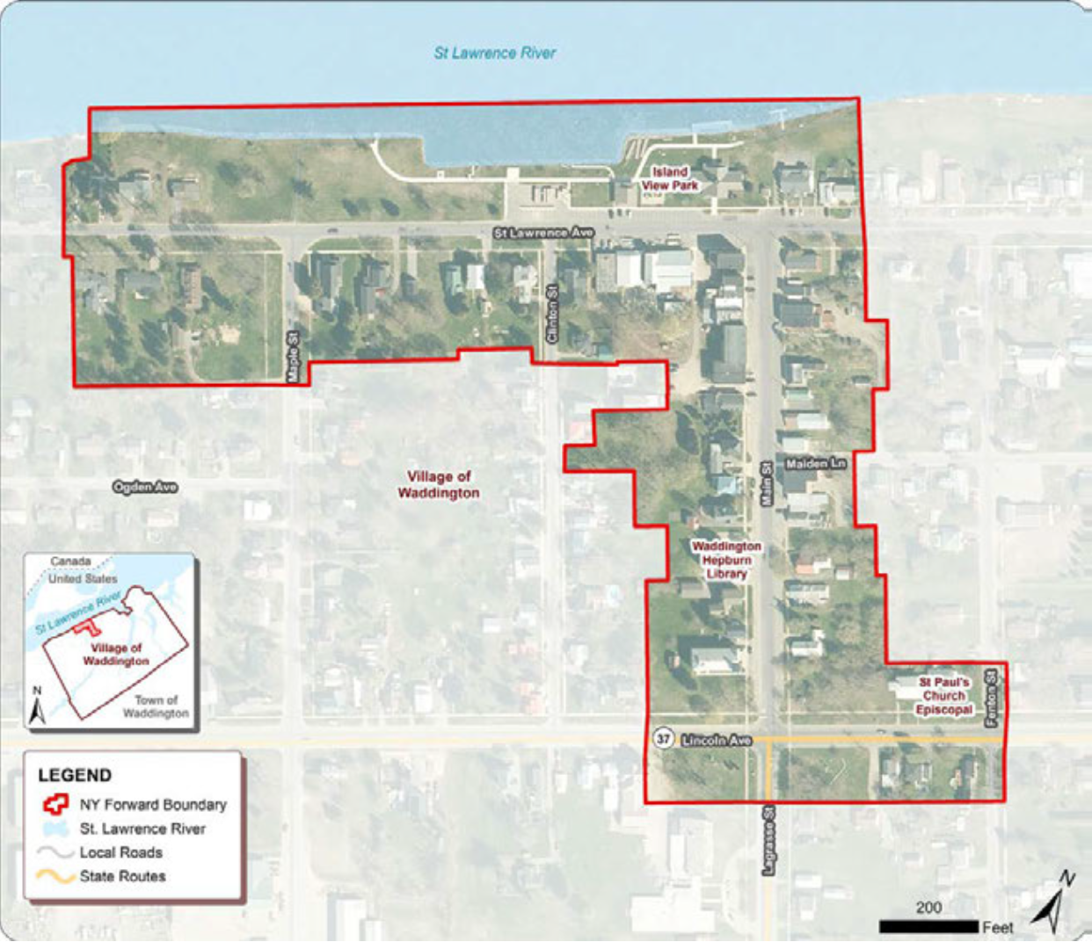

APPLICATIONS MUST BE RECEIVED ON OR BEFORE:

September 31,2026.

Applications must be scanned and submitted by email: DRIWaddington@gmail.com
Or you can complete the Google Form application DRI Waddington Application

The DRI Community will offer funding assistance to eligible projects that enhance and strengthen the Downtown Revitalization Initiative area. Immediate goals of this investment in the Small Projects Fund include streetscape enhancements, historic preservation projects and increased business and economic activity. Long-range goals include increased property values and property tax revenues, the creation of more job opportunities, attraction of new businesses and residents to downtown and ongoing, sustained vibrancy within the downtown neighborhood.

Applicant Eligibility - Applicants who are eligible for DRI assistance include property owners that are:

- Individual
- For-profit entity
- Not-for-profit entity
- Current on property taxes owed to Village of Waddington, St. Lawrence County, and Madrid Waddington School District.
- Free of open building code violations
- Property located within the Village of Waddington designated boundary
- Property is designated commercial or mixed-use (commercial & residential units)
- Property is not receiving additional DRI funding
- The applicant is able to finance the entire project and await reimbursement upon project completion

Eligible Activities
- Building Renovation
  - Façade/storefront renovations
  - Permanently affixed signage and awnings
  - Interior fit-out, HVAC, and mechanical, electrical and plumbing (MEP)
  - Other permanent building improvements
- Business Assistance
  - Permanent commercial machinery and equipment
- Public Art
  - Murals, sculptures, and other significant permanent installations
- Soft Costs
  - Architectural and design, engineering, and environmental testing

Ineligible Activities
Ineligible uses of funds include:
  - Acquisition
  - Demolition
  - Improvements to churches, synagogues, and other religious structures
  - Improvements to municipally-owned buildings used for municipal purposes
  - Non-permanent fixtures, furnishings, appliances, electronics, security systems and business equipment
  - Site work or ancillary activities including septic systems or laterals, grading, parking lots, sidewalks, landscaping, fences, free standing signs
  - General maintenance
  - Reimbursement of cash payments
  - Material purchases or labor completed by property owner

Available Funding
The program offers three types of funding assistance. Grants can never cover more than 75% of your total project cost, meaning you (or another funding source) must cover at least 25% of the cost yourself.
- Building Renovation
- Funding available: $25,000 to $100,000 per building, and never more than 75% of your total project cost
- Eligible improvements include:
  - Building facades
  - Storefronts
- Commercial interiors
- If your building includes residential units, you can receive an additional $25,000 per residential unit, up to a total of $150,000 per building. Grant funds, including this residential bonus, can still never cover more than 75% of your total project cost.
- Minor Exterior Projects
- Funding available: $10,000 to $25,000 per project, and never more than 75% of your total project cost
- Eligible activities include:
- Signage
- Awnings
- Painting
- Small Business Assistance
- Funding available: $10,000 to $50,000 per project, and never more than 75% of your total project cost
- Eligible uses include the purchase of permanent machinery and equipment.

Match Requirements
- Matching funds are calculated on a building-by-building basis.
- In-kind contributions are not eligible as matching funds.

Important Restrictions
- Costs incurred before the grant agreement becomes effective are not eligible for reimbursement.
- Pre-agreement expenses also cannot be counted toward the required match.
- Soft Costs
  - Eligible soft costs include:
    - Architecture, Engineering, and Environmental Testing expenses.
    - Soft costs require matching funds, and in-kind match is not eligible.
    - Soft costs incurred for work on buildings that eventually prove infeasible and do not receive other investments will not be reimbursed with DRI funds. Therefore, reimbursements for soft costs may not be requested as part of a partial payment prior to project completion.
- Proof of Available Financing
  - Property owners are responsible for the total cost of the project.
  - Grants will reimburse property owners at the conclusion of the project after all costs are paid.
  - Proof of available financing through cash in bank, secured loan commitments, and/or project lines of credit is required.
- Payment Process
  - The program operates fully as a reimbursement grant program and the owner is responsible for paying for all agreed upon improvements and payment of grant funds will be made only upon satisfactory completion of the items in the approved scope of work and payment of renovation expenses.
  - No reimbursement shall be paid to the owner until periodic inspections of the work has been completed by the DRI Community or its representative. All completed work shall comply with all applicable building codes and standards.
  - To substantiate work costs, Owners must provide the following:
    - Written contracts
    - Bank documents
    - Copies of invoices for materials and labor
    - Cancelled checks
    - Lien releases
    - Signed Village of Waddington building and code approvals;
    - Any other documents deemed reasonably necessary by the DRI Community or required by HTFC to maintain effective internal controls.
- Cash payments/cash receipts are not permitted and will not be reimbursed.
Application begins on the next page.

APPLICATION FOR FUNDING
APPLICANT INFORMATION:
Applicant Name(s):

Applicant Address:

Daytime Phone Number: Email Address:

Property Owner Name:

Property Owner Address: Phone:

Check all that apply:

- Individual 1 Corporation 1 Not-for-Profit
- Owner of the building 1 Lease the building 1 Lease a portion of the building

Proposed Improvements:

- Equipment 1 Interior Improvements
- Exterior Improvements 1 New Signage

Eligibility Requirements:

- Current on property taxes owed to Village of Waddington, and St. Lawrence County
- Free of open building code violations
- Property located within the Village of Waddington DRI designated boundary
- Property is designated commercial or mixed-use (commercial & residential units)
- Property is not receiving additional DRI funding
- The applicant is able to finance the entire project and await reimbursement upon project completion
BUILDING INFORMATION:

Property Address:

Within DRI Boundary (see map): 1 YES 1 NO

Name of Business(es):

Number of Commercial Units:

Number of Residential Units:
BUILDING IMPROVEMENTS:
Complete description of exterior or interior improvements and signage: (Please include DRI funded project and any other improvements proposed)

Please provide a schedule for the proposed renovations:

Please explain how the proposed project addresses the goals of the DRI Strategic Investment Plan and how you think this project will contribute to the transformation of Waddington.
EQUIPMENT:
Please describe the proposed use of funds for the purchase of permanent commercial business equipment:
PROPOSED BUDGET:
 | TOTAL ACTIVITY COST | DRI AMOUNT | Property Owner Contribution AMOUNT | SOURCE of Contribution Amount |  | DOLLAR AMOUNT | CURRENT STATUS of Contribution
Architectural Fees | $ | $ | $ | 1 |  | $
 |  |  |  | 2 |  | $
 |  |  |  | 3 |  | $
Engineering Fees | $ | $ | $ | 1 |  | $
 |  |  |  | 2 |  | $
 |  |  |  | 3 |  | $
Signage | $ | $ | $ | 1 |  | $
 |  |  |  | 2 |  | $
 |  |  |  | 3 |  | $
Equipment | $ | $ | $ | 1 |  | $
 |  |  |  | 2 |  | $
 |  |  |  | 3 |  | $
Construction/  Rehabilitation | $ | $ | $ | 1 |  | $
 |  |  |  | 2 |  | $
 |  |  |  | 3 |  | $
SUBTOTAL | $ | $ | $ |  | Choose from: Anticipated, Committed, In-Hand, Donated or Requested
CONTINGENCY (%) | $ | $ | $
TOTAL CONSTRUCTION COST | $ | $ | $
Please include a proposed budget for all expenses for each proposed project:

CERTIFICATION:
I certify that all of the information, statements and representations contained in this application, and in all attachments and supporting material, are, to the best of my belief, true, accurate and complete.

I acknowledge that all appropriate permits and approvals, site specific environmental review, and State Historic Preservation Office (SHPO) review, as required for work on historic buildings, must be complete for eligible activities prior to the start of construction.

I acknowledge that, as part of the evaluation process, the Village of Waddington or its representatives will conduct a site visit to this property and may need access to the interior and exterior of the building.

Costs incurred for work on buildings that eventually prove infeasible and do not receive other investments will not be reimbursed with DRI Business Assistance Funds; therefore, reimbursements for soft costs may NOT be requested as part of a partial payment prior to project completion.

I have read and understand all Village of Waddington DRI Business Assistance Fund Requirements as outlined in the Program Guide.

Signature of Applicant Date

